(Approx. 468 words)

Some Useful Technology
by Jeff Wilkinson, President, Sun City Summerlin Computer Club
https://www.scscc.club
president.scscc (at) gmail.com
I recently decided to put music on our patio for an upcoming party. While we have an intercom station on the patio, the sound was not acceptable for music. So, I decided to upgrade. I investigated various methods, from wired extension speakers for my existing stereo, multiple Amazon Echo’s, and a few other complex or pricey solutions. Since I had recently “ripped” a whole series of my favorite music CDs and loaded them on a Plex server along with several downloaded music selections, I wanted access to that growing music collection. In addition, I had compiled multiple playlists for use in different situations, parties, easy listening, smooth jazz, 60’s music, etc.

A sale on the Echo Smart Speaker, 4th generation, prompted my purchase of two, intending to use the multi-room music feature to sync them together. In addition, I could locate them on the patio since I had conveniently placed electrical outlets available. The Echo Smart Speakers sounded good and were perfectly acceptable for a party with multiple conversations and ambient noise. I put the Echo Smart Speakers on the patio, and they worked fairly well, although there appeared to be some syncing problems.

About that time, I came across a BOGO (Buy One Get One) offer for Santana Samba 20-watt wireless speakers and thought I would give them a try. I was totally surprised at their performance. The sound was excellent; the pairing via Bluetooth to a single Echo Smart Speaker was easy, and I could pair the two speakers together for excellent sound given their small size. With my new configuration, I played music from my Plex server with a simple command to Alexa: “Ask Plex to play … ” virtually any song title, artist, or playlist in my growing collection. I can also access Sirius radio and Amazon music, offering me a wide choice of streaming music.

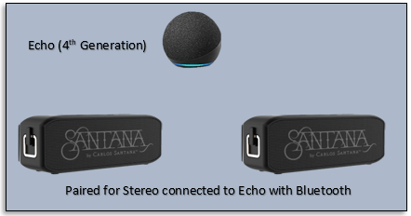

The example above shows a practical use of some amazing technology available to us today. Here’s another … I recently started using a Windows 10 feature, “Your Phone.” You can mirror your Android or iOS smartphone to your PC screen with a little setup and configuration. With this app installed on your phone, you can manipulate your phone via your PC keyboard, open and run phone apps, view your picture gallery, and do virtually anything you can do on the phone! For example, I find it easier to type and send a text message from the PC keyboard!

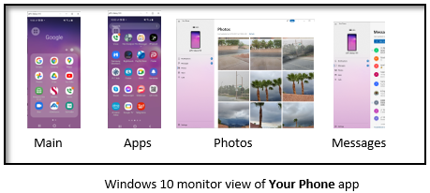

While many of us didn’t grow up immersed in technology, much of it is very useful and can add a new dimension to everyday tasks. Your computer club strives to help users explore existing features and introduce new technology to our members.

